
Year 8 Mathematics
Mini Test
Circles

Resources: one A4 page of notes and a calculator

Name: ________________Solutions__________ / 23 marks Time: 25 mins

Full working out must be shown to get full marks. Attempt all the questions.
Round answers to one decimal place.

Question 1 (3 marks)
Name the dotted line on each circle
Diagram | Name
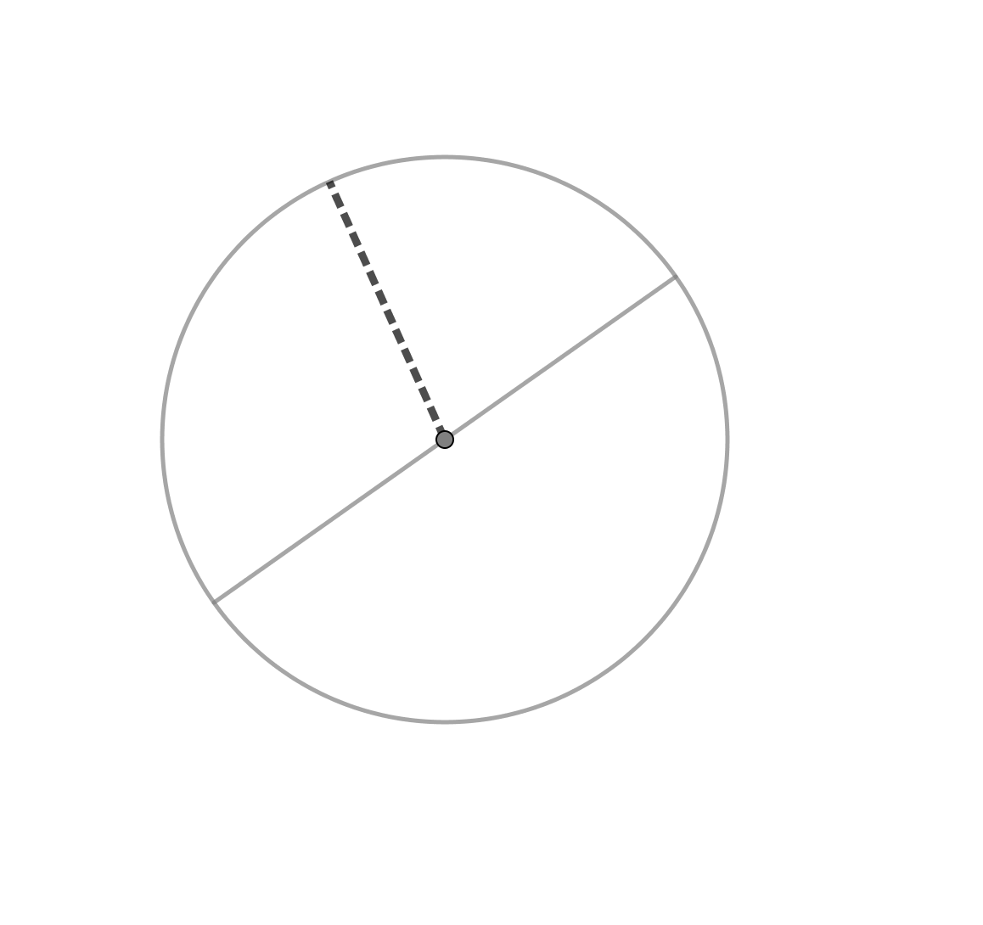 | Radius
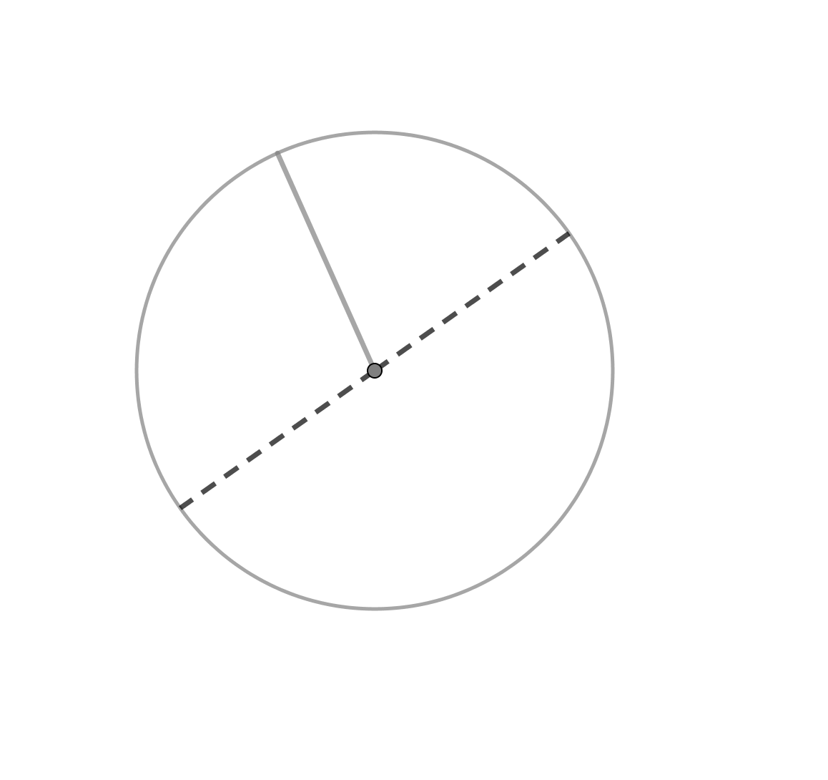 | Diameter
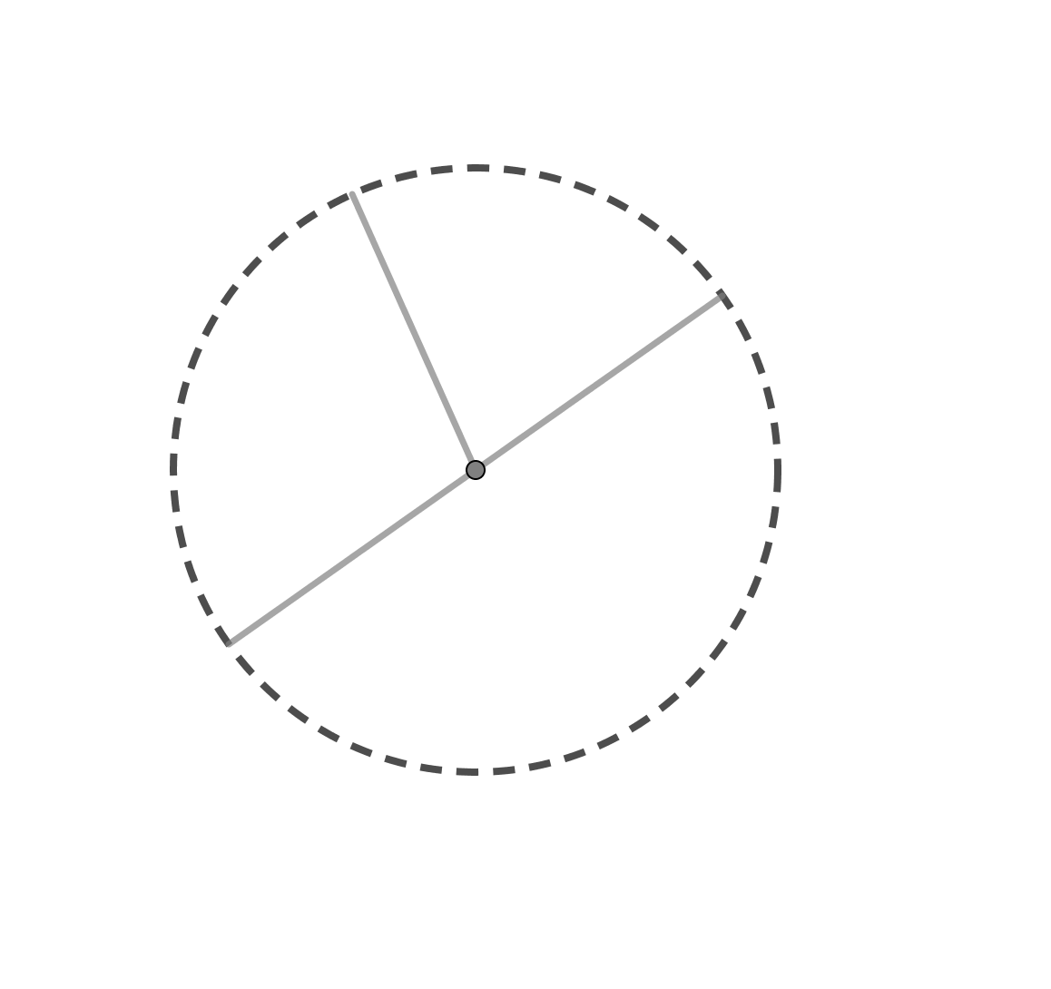 | Circumference

Question 2 (8 marks)
Find the circumference and the area of the following circles
Circle | Circumference | Area
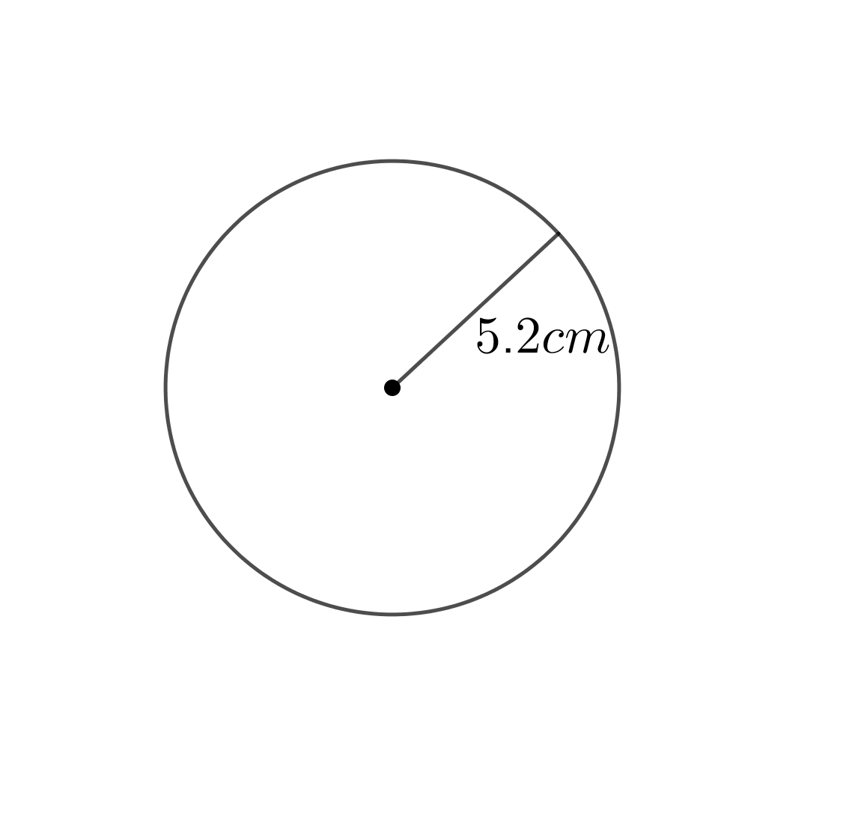 | $$2×π×5.2$$  $$=10.4π$$  $$=32.7cm$$ | $$π×{5.2}^{.2}$$  $$=84.9{cm}^{2}$$
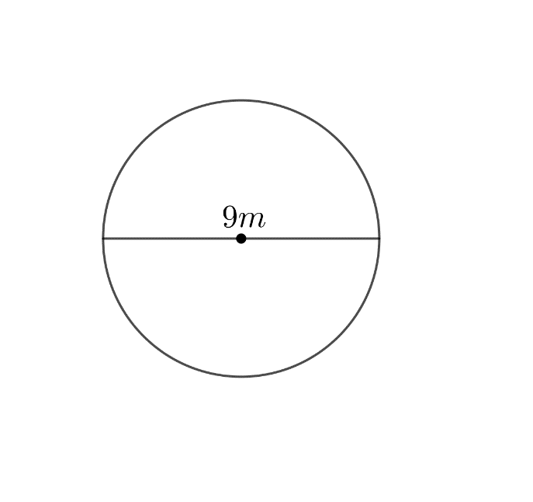 | $$π×9$$  $$=9π$$  $$=28.3m$$ | $$π×{4.5}^{.2}$$  $$=63.6m^{2}$$

Question 3 (3 marks)
Find the area of the semi-circle

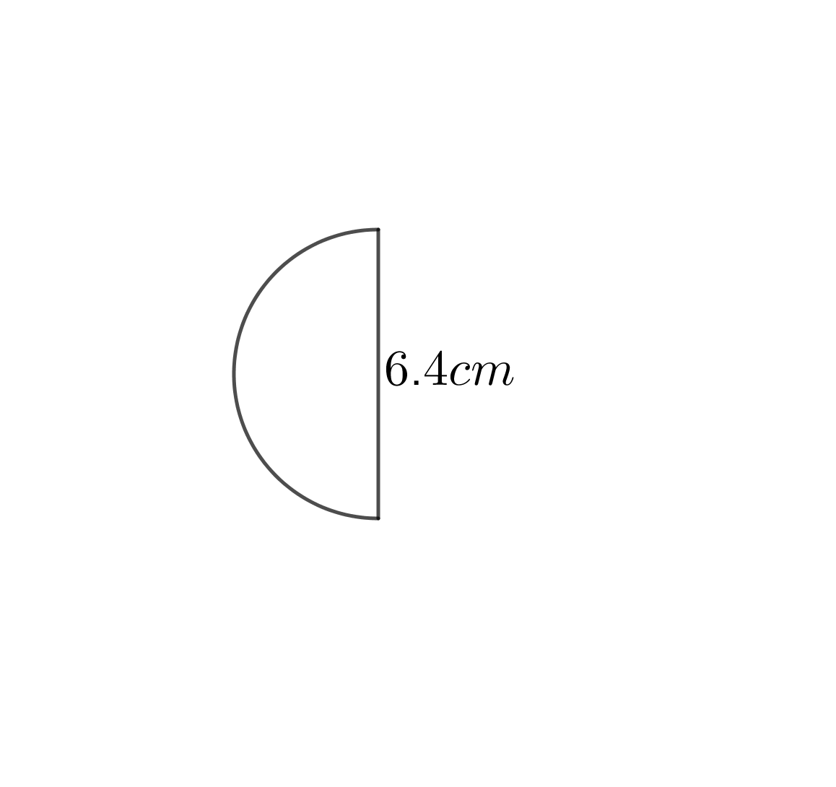
$$\frac{1}{2}×π×{3.2}^{.2}$$
$$=16.1{cm}^{2}$$
Question 4 (3 marks)
A yoyo at the end of a string moves through a quarter circle, as shown below. Find the curved distance travelled by the yoyo.
$$\frac{1}{4}×π×140$$
$$=110.0 cm$$

Question 5 (6 marks)
- A child’s bike tyre has a circumference of 90cm. What is the radius of the circle?

$$d=\frac{90}{π}$$
$$d=28.6cm$$
$$r=14.3cm$$

- An adult bike tyre has a diameter of 70cm. How many full turns will the tyre make if the bike travels 500m?

$$π×70$$
$$=219.9cm=2.199m$$
$$500÷2.199$$
$$=227.3$$
$$∴227 turns$$

End of Test

